Bahria University

# Computer Science Department



**Submitted By:**

* MUHAMMAD FARAZ
* ENROL:02-134171-147
* BS(CS)_4B
* REGISTRATION NUMBER:48536

**Submitted to:**

* Miss Laraib Tahir

**Submission Date:**

[23/09/2018]

**DEPARTMENT OF COMPUTER SCIENCE**

**BAHRIA UNIVERSITY, KARACHI CAMPUS**

|  |
| --- |
| EXERCISES |
|

**TASK # 01**

Create a replica of EMP table with all the records in it.

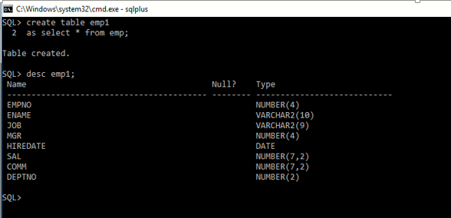

**TASK # 02**

Add a column ‘Address’ in it.

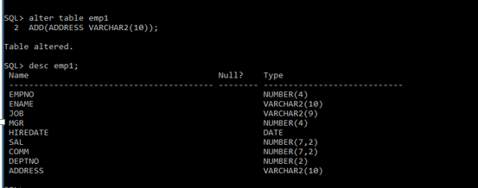

**TASK # 03**

Drop column ‘Address’ from it.

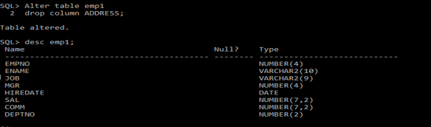

**TASK # 04**

Add columns ‘House No’ character ,’Street No’ numeric, ’Area’ character ,’City’ character in it with the respective data types.

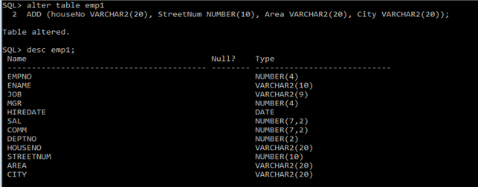

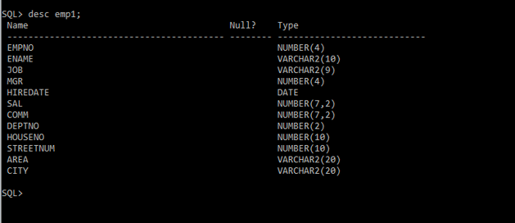

**TASK # 05**

Change the data type of ‘House No’ from character to numeric.

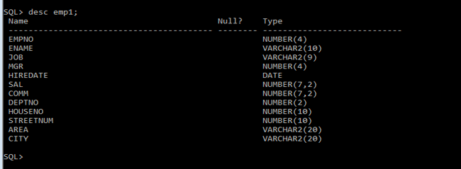

**Task # 06**

Create the Data Definitions for each of the relations shown below, using SQL DDL. Assume the following attributes and data types:

**FACULTY**: FacultyID (integer, primary key) FacultyName (25 characters)

**COURSE**: CourseID (8 characters, primary key) CourseName (15 characters)

**CLASS:** ClassID (8 characters) CourseID (8 characters foreign key) SectionNo (integer) Semester (10 characters)

**STUDENT:** StudentID (integer, primary key) StudentName (25 characters) FacultyID (integer foreign key)

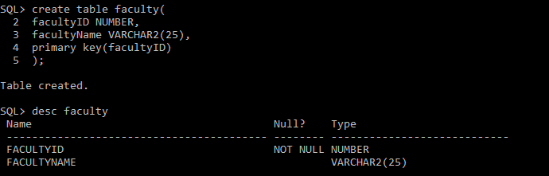

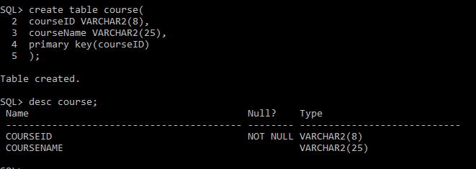

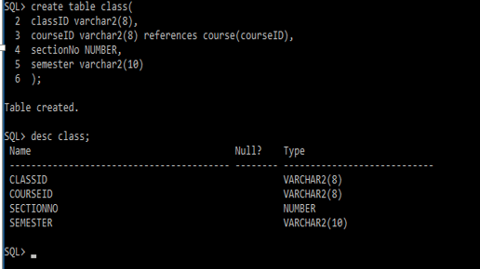

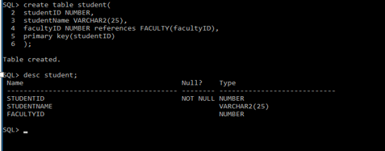

**TASK # 07**

How would you add an attribute, CLASS, to the STUDENT table?

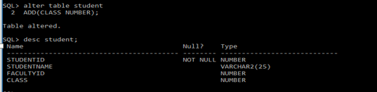

**TASK # 08**

How would you remove the FACULTY and STUDENT tables?

